Chapter 1.1 Collision Theory and Equilibrium

Video showing a successful collision: https://www.youtube.com/watch?v=IkqoBbFZV4Q

http://www.chem.iastate.edu/group/Greenbowe/sections/projectfolder/animations/NO+O3singlerxn.html

H2 + I2 2HI

first later later still
successful collision (reaction)

- Describe the 3 requirements of a successful collision according to collision theory?

____________________________________________________________________________

____________________________________________________________________________

____________________________________________________________________________

____________________________________________________________________________

____________________________________________________________________________

- What is another scientific term used to describe the number of successful collisions in a given time?

____________________________________________________________________

- Collision theory can help us understand the factors that affect reaction rate. List 5 factors that affect the rate of reaction.
a.________________________ b.__________________________
c.________________________ d.__________________________
e.________________________ f.__________________________

Now we will look at each factor in detail:

Effect of concentration

low conc. both high conc. blue high conc. both low conc. red

i. _________ chance of collision i._________ chance of collision i. ____________ chance of collision
ii. speed of reaction_________ ii. speed of reaction_____________ ii. speed of reaction_____________

iii. amount of product produced iii. amount of product produced iii. amount of product produced

______________________ _______________________ ______________________
- There are a few golden rules for rates of reaction that are important to stamp indelibly on your brain prior to learning about equilibrium.

- Most reactions do not go to completion. In other words, _________________________________
______________________________________________________________________________
______________________________________________________________________________
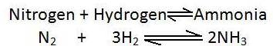
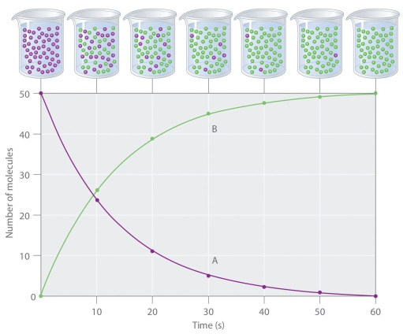
- When dealing with rates of reaction only look at the concentration of _____________________ never worry about the concentration of the__________________________________ unless they ask you about the rate of the ____________________reaction.

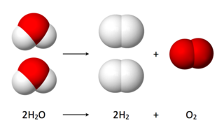

- Increasing temperature always increases the
_______________________________________________ for both the ________________and ____________________reaction, but it can have a very different effect on equilibrium.
For every 10 degree Celsius rise in temperature the rate of reaction approximately
_________________.
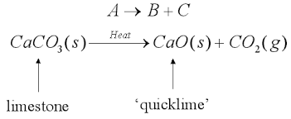
For example:

- Only look at the state of reactants when considering rates of reaction. Explain this statement and what this might involve doing to ascertain rates? Give examples.
__________________________________________________________________________________
__________________________________________________________________________________
__________________________________________________________________________________
__________________________________________________________________________________
__________________________________________________________________________________
__________________________________________________________________________________
__________________________________________________________________________________
Example Problem:
Given the following reaction:
CaCO_{3(s)} + HCl_{(aq)} CO_{2(g)} + H₂O_{(l)} + CaCl_{2(aq)}
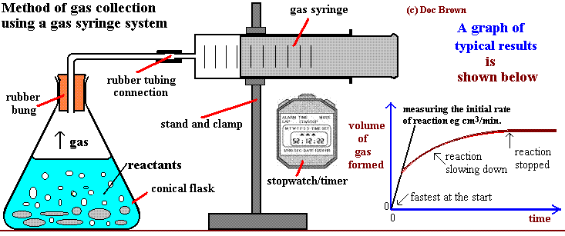
Fill in the table below describing how the following changes to the reaction would affect the rate of reaction.
Change made to system | Predict outcome | Use collision theory to justify your prediction
Raise the temperature by 20ºC |  | ______________________________________________  ______________________________________________  ______________________________________________
Use 0.1 M HCl instead of 1.0 M HCl |  | ______________________________________________  ______________________________________________  ______________________________________________
Crush the CaCO3 pellets into a powder |  | ______________________________________________  ______________________________________________  ______________________________________________
Add CaCl2 to the original solution |  | ______________________________________________  ______________________________________________  ______________________________________________
Add a chemical catalyst |  | ______________________________________________  ______________________________________________  ______________________________________________
Understanding how catalysts affect rates of reaction:
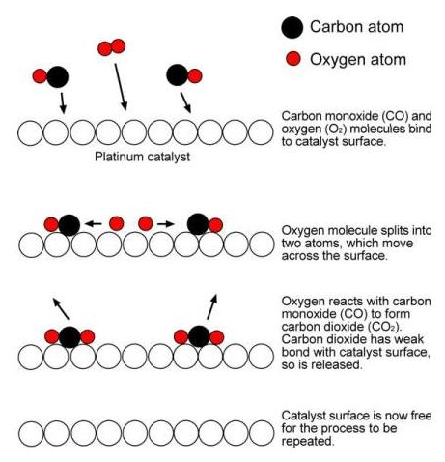
- Chemical catalysts are very different from enzymes in two ways. Explain how they are different in terms of:
- structure
- affect on rate of reaction of forward and reverse reactions
- affect temperature has on these two different forms of catalysts.
_________________________________________________
_________________________________________________
_________________________________________________
_________________________________________________
_________________________________________________
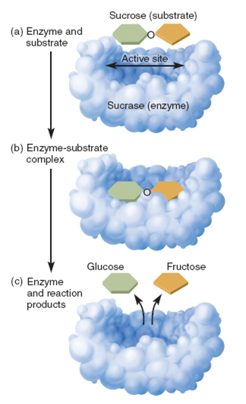
_________________________________________________
_______________________________________________________________
_______________________________________________________________
_______________________________________________________________
_______________________________________________________________
_______________________________________________________________
_______________________________________________________________
_______________________________________________________________
_______________________________________________________________
- How do I know whether the enzyme affects the forward or reverse reaction?
_____________________________________________________________________________________
_____________________________________________________________________________________
For example:
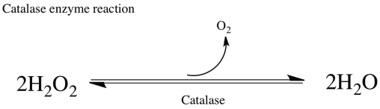
- Catalase reaction affects the rate of reaction in the ___________________direction only. The result would be to have more_________________than
__________________ produced as a result.
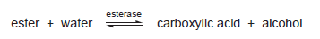
- The enzyme for this reaction is called_________________
and based on how this reaction is written the rate of the ___________ reaction will be greater than the_____________reaction, thus resulting in more
_______________________________________________________________________________
Reversible Reactions
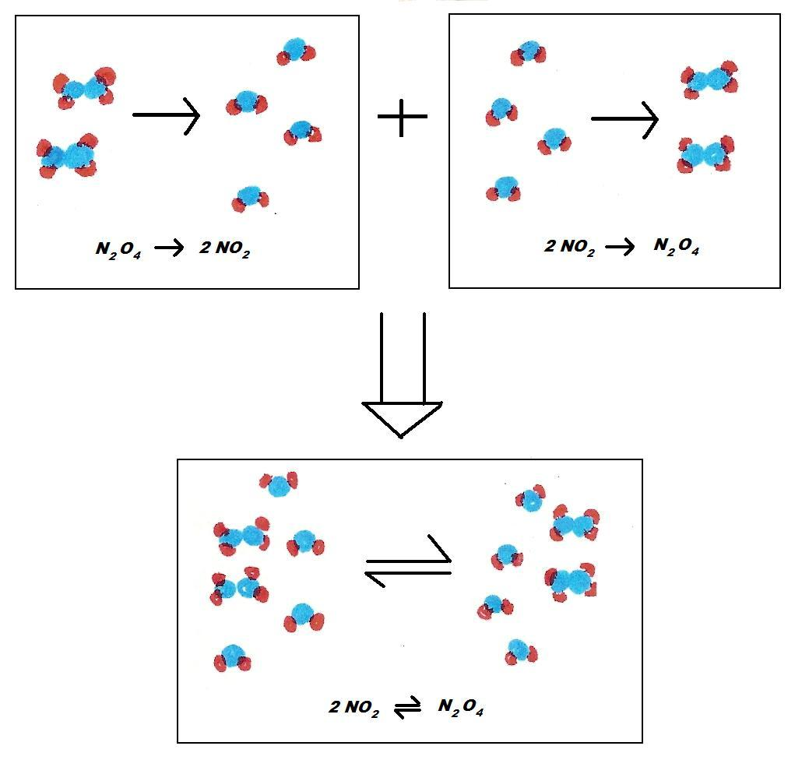
- What does it mean when we say a reaction is reversible?

_______________________________________

_______________________________________
_______________________________________
_______________________________________
_______________________________________
_______________________________________
_______________________________________

- a) Write the equation for the reaction in the diagram to the right.
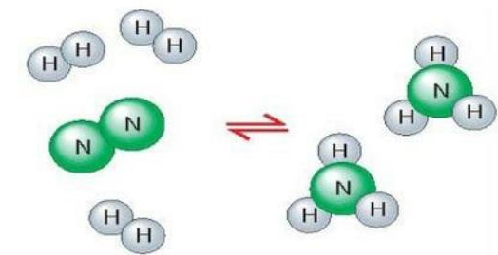
____________________________________________________

b) Write only the forward reaction

_____________________________________________________

c) Write only the reverse reaction

_________________________________________________________

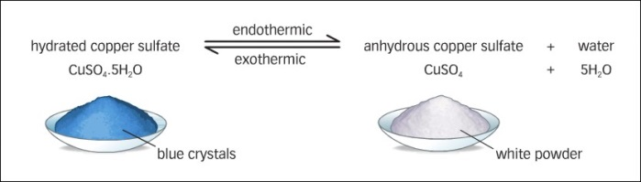
- a) Write the forward and reverse reactions for copper (II) sulfate pentahydrate.

- Forward rxn:_______________________________________________________

- Reverse rxn:________________________________________________________

b) When the forward reaction is endothermic what do you notice about the reverse reaction?

_________________________________________________________________________________

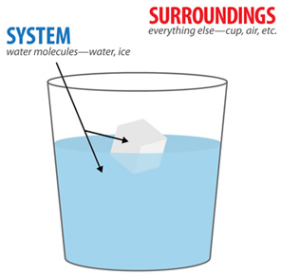
- What is a chemical system?

_______________________________________________________________

_______________________________________________________________

_______________________________________________________________

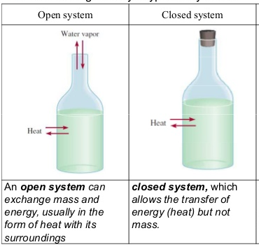
- Describe the difference between an opened and closed system.

__________________________________________________________________________________________________________________________________________________________________________
__________________________________________________________________________________________________________________________________________________________________________

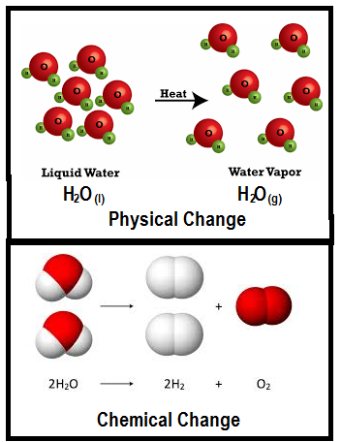
- Explain the difference between a physical and chemical change that can occur inside a system.

__________________________________________________________________________________________________________________________________________________________________________
__________________________________________________________________________________________________________________________________________________________________________

- Are all physical changes reversible? Explain and give examples.

________________________________________________________________________________

________________________________________________________________________________

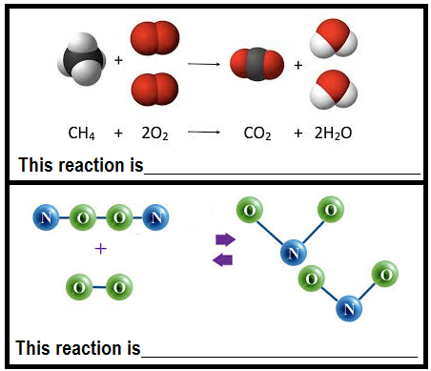
- Are all chemical changes reversible? Explain.

___________________________________________________
__________________________________________________________________________________________________________________________________________________________________________
- Explain why some reactions are irreversible and why they are irreversible.

____________________________________________________________________________________
_______________________________________________________________________________________________________________________________________________________________________________________________________________________________________________________________

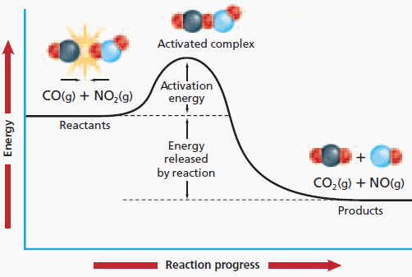
- What are activation energy and the activated complex?

___________________________________________
___________________________________________
___________________________________________
___________________________________________
___________________________________________
___________________________________________
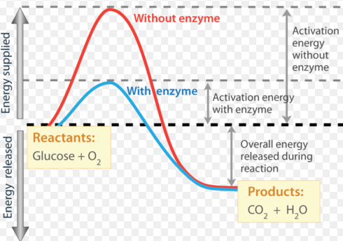
- a) Write the formula equation for this reaction.

___________________________________________

b) Would you need an open or closed system in order for this reaction to have a hope of being reversible? Explain.

_____________________________________________

_____________________________________________

_____________________________________________

c) Refer to the diagram above and explain which of these reactions (red or blue) is more likely to occur…or do they have the same likelihood? What should you be looking at to make this decision? Assume that both reactions have the same scale on the x and y axis.

________________________________________________________________________________
________________________________________________________________________________
________________________________________________________________________________
d) Which of these two reactions (red or blue) is more likely to be reversible? Explain.

________________________________________________________________________________
________________________________________________________________________________
________________________________________________________________________________
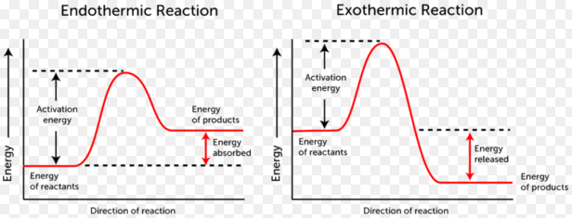
- Refer to the diagram above and explain which of these reactions is more likely to occur…or do they have the same likelihood? What should you be looking at to make this decision? Assume that both reactions have the same scale on the x and y axis.

________________________________________________________________________________
________________________________________________________________________________
________________________________________________________________________________

- Remember kinetic energy distribution diagrams for reactions?
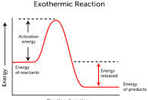
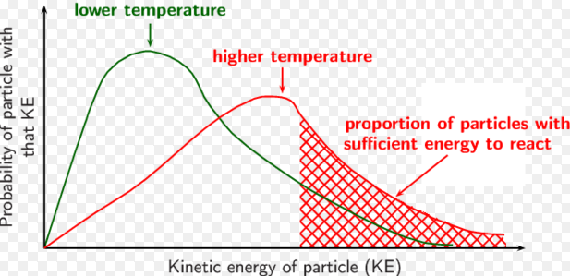

- Where is the Activation Energy on this graph? If this is representing an exothermic reaction then where will the Activation Energy for the reverse reaction require more or less kinetic energy? Draw where the Activation energy for the reverse reaction would be on this graph and explain your answer below.

_______________________________________________________________________________
________________________________________________________________________________
________________________________________________________________________________
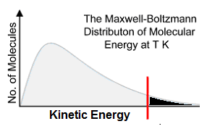
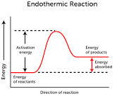

- Label the Activation Energy (Ea) on this graph? If this is representing an endothermic reaction then where will the Activation Energy for the reverse reaction require more or less kinetic energy? Draw where the Activation energy for the reverse reaction would be on this graph and explain your answer below.

_______________________________________________________________________________
________________________________________________________________________________
________________________________________________________________________________
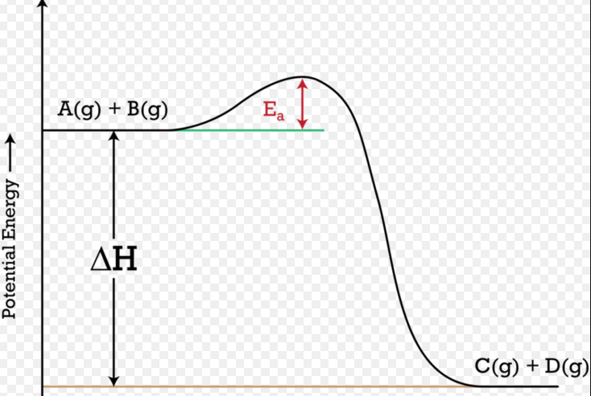
Review:
- Does this reaction have a high or low likelihood of being reversible? Explain your answer.
___________________________________________________
___________________________________________________
___________________________________________________
___________________________________________________

